Camera angle measurements calibration

|  |  |
| --- | --- |
| Distance | Angle |
| 15’ | 60.1 |
| 30’ | 59.2 |
| 60’ | 58.5 |
| 90’ | 58.8 |
|  |  |
|  |  |
|  |  |

150

600

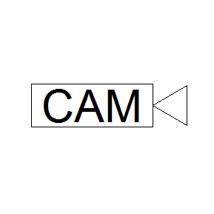 15o